Firstly I started snort and kept it as listning mode and updates the alerts to the log file
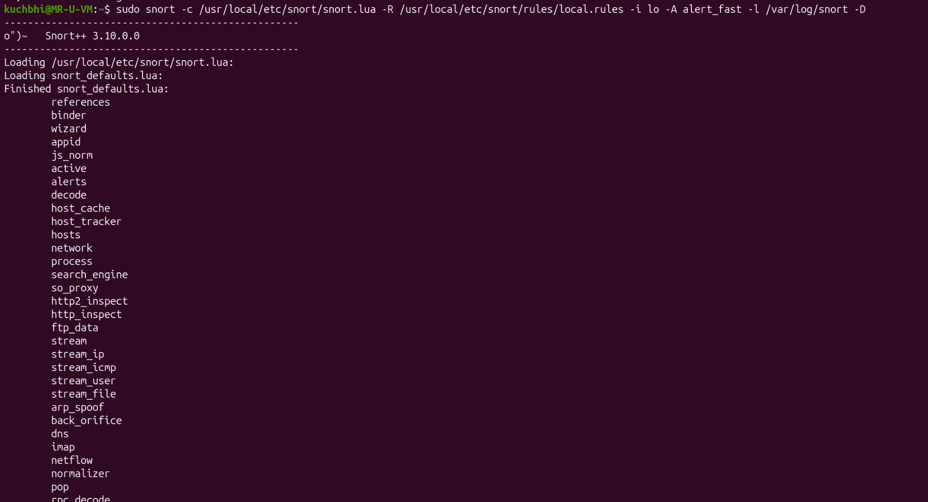
Then I opened the log file using tail to actively monitor the alerts
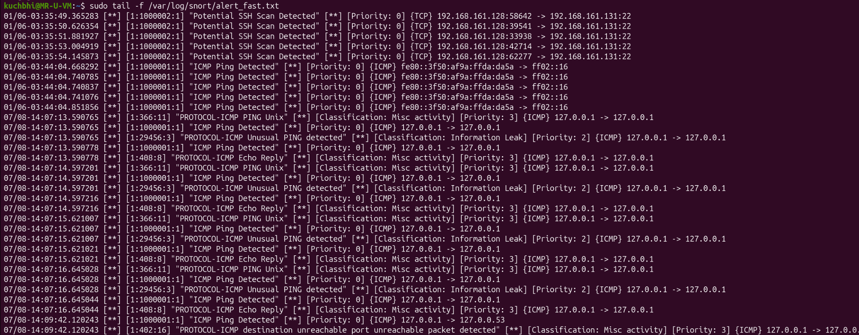
Then I added the log file in monitoring on splunk
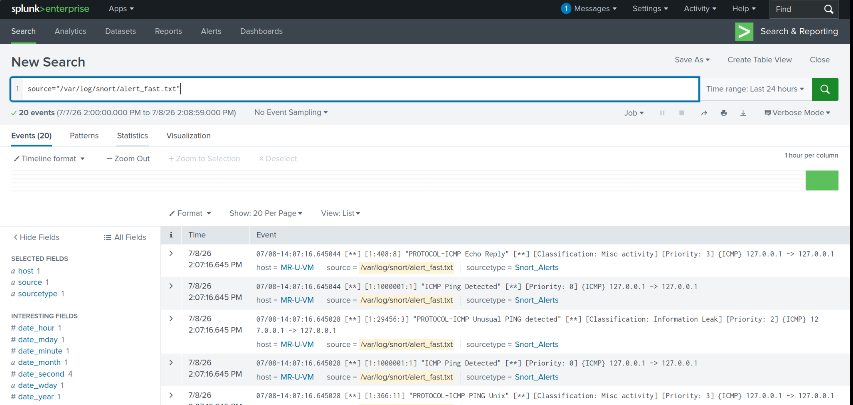

source="/var/log/snort/alert_fast.txt"
| timechart count by Event
| streamstats avg(count) as baseline stdev(count) as standard_deviation window=5
| eval anomaly_threshold = baseline + (standard_deviation * 2)
| eval is_anomaly = if(count > anomaly_threshold, "YES - THREAT DETECTED", "Normal Baseline")

